Activity Practice 1: Decomposition by Business Capability
Goal: Identify clear, independent microservices based on the menu structure shown in your dashboard image (Organizations, User Management, Majors, Cohorts, Tuition Settings).
1. Identify Core Business Capabilities
Based on the dashboard image, we can group the features into the following domains:
- Identity & Access: Managing users, logins, and roles (Admin, Student, Lecturer).
- Academic Structure (Curriculum): Managing the static data of the university (Majors, Modules, Knowledge Blocks, Organizations).
- Student Lifecycle: Managing student-specific data, cohorts, and class assignments.
- Finance: Managing tuition settings and fees.

2. Define Microservices
Here is the proposed decomposition for your system:
Business Capability | Proposed Microservice | Data Owned (Entities)
Identity & Access | Identity Service | Users table (username, password hash, role), Tokens.
Academic Structure | Curriculum Service | Departments, Majors, Modules, Knowledge Blocks.
Student Lifecycle | Student Record Service | Students (profile), Cohorts, Class Enrollments.
Finance | Tuition Service | Tuition Settings, Invoices, Payment History.
Lecturer Management | Lecturer Service | Lecturers, Department Assignments.

3. Define External Dependencies
The Student Management System acts as the core, but it must talk to outside systems:
- Email Service Provider (SMTP): For sending password resets and tuition notifications.
- Payment Gateway (e.g., VNPay/Stripe): For students paying tuition online.
- LMS (Learning Management System): (Optional/Future) To sync course data with a system like Moodle.

Activity Practice 2: Defining Service Contracts
Goal: Establish the API Endpoints for communication. We will focus on the interaction between the Student Record Service (Producer) and the Tuition Service (Consumer).
Scenario: The Tuition Service needs to calculate fees. It needs to know which Major and Cohort a student belongs to, but it cannot access the Student Database directly.
1. Define the Student Service's API (Producer)
This service exposes student data to other services.
Endpoint | HTTP Method | Description | Data Returned
/api/v1/students/{id} | GET | Retrieve core details of a student (Major, Cohort). | Student Object (JSON)
/api/v1/students | GET | Get a list of students (with filters). | List of Student Objects
/api/v1/students | POST | Register a new student. | Created Student Object

2. Define the Tuition Service's Interaction (Consumer)
- Action: Admin clicks "Calculate Tuition" for a specific student in the Tuition Module.
- Requirement: The Tuition Service requires the major_id and cohort_year from the Student Service.
- Violation Check: The Tuition Service must NOT run a SQL query like SELECT * FROM students.
- Correct Approach: The Tuition Service sends an HTTP GET request to http://student-service/api/v1/students/{id}.

Activity Practice 3: C4 Model (Level 1: System Context)
Goal: Create a high-level visual map showing the boundaries of the Student Management System and its external interactions.
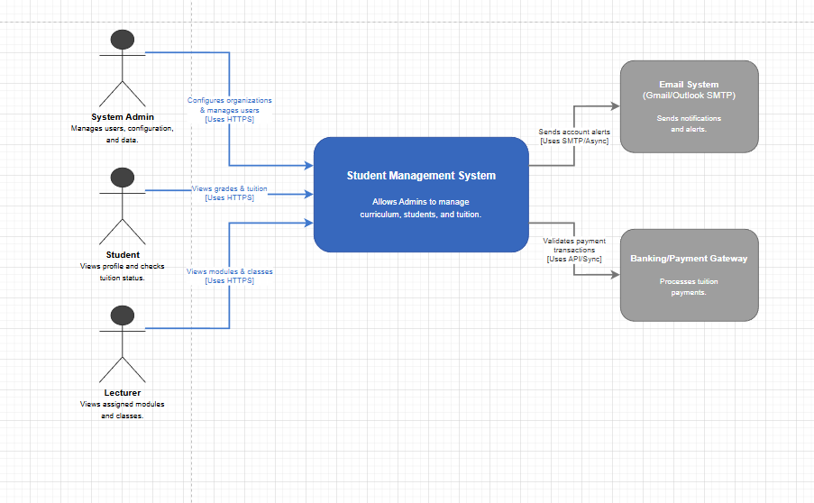
Activity Practice 4: Communication Strategy
Goal: Distinguish between Synchronous (Blocking) and Asynchronous (Non-blocking) communication in the new architecture.
Interaction | Service / Component | Communication Type | Rationale
Login / Auth | Frontend -> Identity Service | Synchronous (HTTP/REST) | The user cannot proceed to the dashboard until their credentials are verified. Immediate response required.
Calculate Tuition | Tuition Svc -> Student Record Svc | Synchronous (HTTP/REST) | The tuition calculation needs the student's current Major immediately to show the correct fee.
Send Welcome Email | Identity Svc -> Email System | Asynchronous (Message Queue) | Creating a user is fast. Sending an email takes time (1-2s). We shouldn't make the Admin wait for the email to send before saying "Student Created".
Bulk Import Students | Frontend -> Student Record Svc | Asynchronous (Batch Job) | Uploading 1000 students takes time. The system should accept the file and process it in the background.

